ME 557: Homework-4 Report

Gaurav Bhatt

[gbhatt@iastate.edu](mailto:gbhatt@iastate.edu)

**Part 1 :**

Background: Landscape(windows.bmp) and color gradient(color_gradient.bmp)

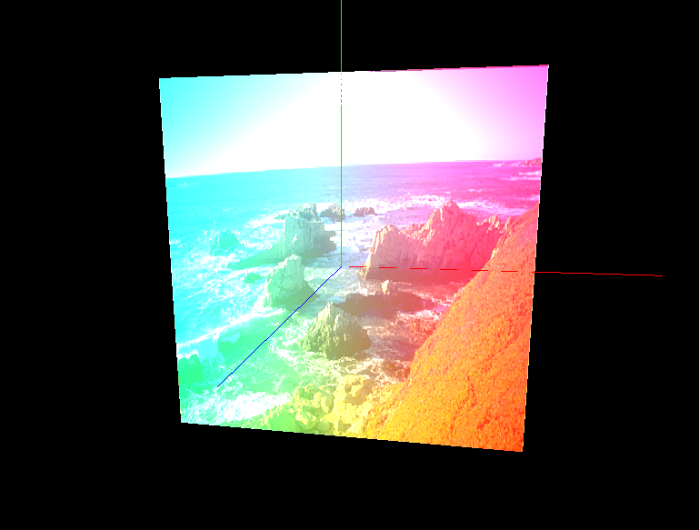

**Part 2:**

Background: Landscape(windows.bmp) color gradient(color_gradient.bmp) and Animal (puppy.bmp)

Mode: Default (glBlendFunc(GL_SRC_ALPHA, GL_ONE_MINUS_SRC_ALPHA);)

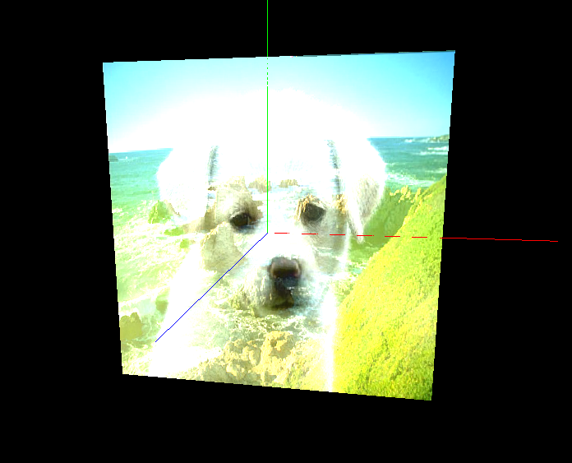

**Part 3:**

Background: Landscape(windows.bmp) color gradient(color_gradient.bmp) and Animal (puppy.bmp)

Mode: (glBlendFunc(GL_SRC_COLOR, GL_DST_COLOR);)

